Shraddha Kapoor is going to become an astronaut   
Though the last few films of Actress Shraddha Kapoor may have been flop, but for her upcoming movie "Haseena Parkar", she is receiving great accolades.  
Sources say Shraddha has been finalized for the film "Chanda Mama Dur Ke". In this film, she is accompanied by Sushant Singh Rajput and Nawazuddin Siddiqui. As per the reports of Mumbai Mirror - Sushant, Nawaz and Shraddha are all is playing the role of Astronaut in the film.

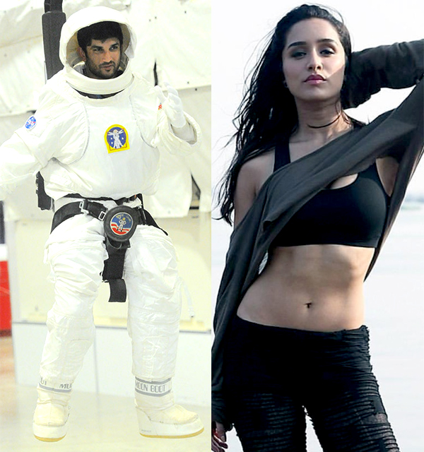Shraddha will soon start training of her role in "Chanda Mama Dur Ke". Sushant Singh Rajput recently returned from NASA after taking training of his character. There he has attented many workshops. The film will be shot in Mumbai, Delhi and Hyderabad.  
Currently, Shraddha is busy promoting "Haseena Parker". The film will be released on 18th August. Apoorva Lakhia has directed the film. At the same time, Nahid Khan is the producer of this film. In this film, Kishore Kapoor will play the role of Dawood Ibrahim and Shraddha will play the role of his sister Haseena Parker. Sweet Shraddha will be seen in a very bold and unqualified style.

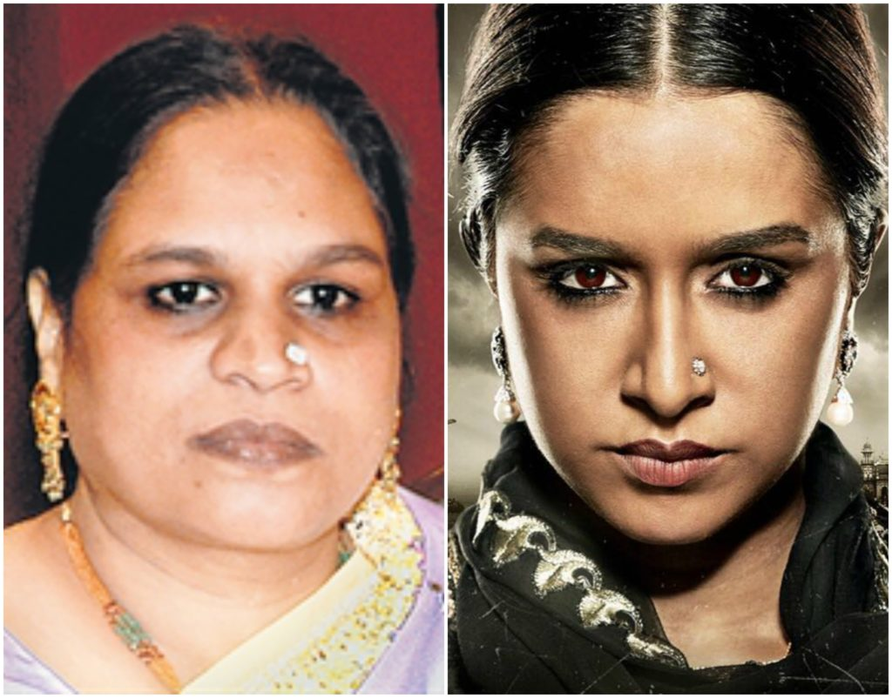Significantly, Haseena Parker died on July 6, 2014. There were 88 cases registered against Hasina, but she went to court only once in her life. Reports say Hasina used to handle Rs 1000 crore of the underworld empire of her brother. This is happening for the first time in the Indian film industry when the real life sister-brother will also be seen in the role of sister and in the role of brother.